8051 quiz game project (code + proteus simulation)
This post provides a simple quiz show code ( using c language ) for 8051 micro-controller ( e-g for AT89C51 or AT89C52 etc ). In this quiz show, multiple choice questions are asked from the user and the user has to answer the correct answer. 2 player support is also available, with one user ( called userA in code ) on the keypad and the other user ( called userB in code ) on the PC with hyperterminal open ( i-e he/she is playing on the UART).
The code and Proteus simulation is given in the 'Downloads' section at the bottom of this page. It is assumed that you know how to interface LCD and keypad with 8051 micro-controller. If you don't, then please read this post first.

Features of this game
- Support for two Users, userA and userB.
- UserA on keypad.
- UserB on keyboard (PC with UART connectivity).
- Mode selection in the start.
- Select mode0 for single player on keypad.
- Select mode1 for double players.
- Mode0 means,
  - A question is displayed on the screen and the user is shown 4 possible answers.
  - User has to decide the answer and press the corresponding number (i-e 1 or 2 or 3 or 4).
  - Correct answer gives +5 marks while wrong answer gives -2.
  - A total of 3 questions are asked from the user randomly picked from a total of 6 questions stored.
  - At the end, result is displayed and pressing any key will restart the system.
- Mode1 means,
  - A question is displayed on the LCD + PC screen simultaneously and options are also displayed. The user who presses 0 button first is given the chance to give answer first.
  - If the user gives wrong answer then -3 marks are deducted, and for a correct answer +5 marks are given to the user. If first user gives wrong answer then second user is given the chance to answer the question, if he can answer +5 points are given if he can't no marks are deducted.
  - A total of 3 questions are asked from the users randomly picked from a total of 6 questions stored.
- At the end result is diplayed and pressing any key will restart the system.

Screen Shots
When you open Proteus simulation then "welcome" message is displayed on the screen. It is shown below in the figure.
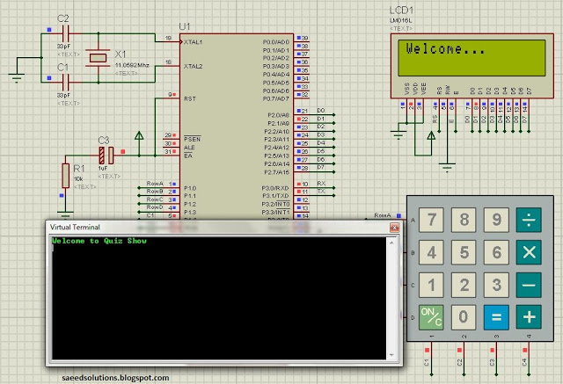
Figure 1. 8051 based quiz game start up
In the above figure, UserA is playing with the LCD and keypad. While the UserB is playing with the 'Virtual Terminal'.
After displaying welcome message, LCD shows mode selection screen which is shown below.
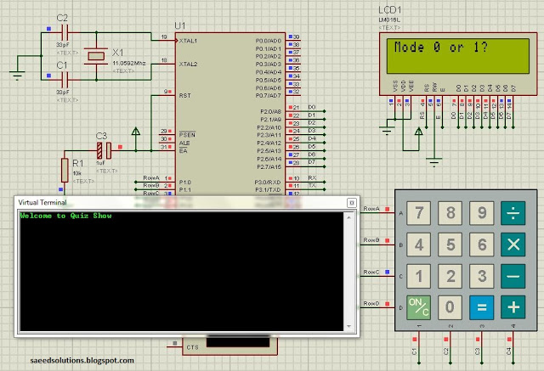
Figure 2. Mode selection for quiz show
After pressing 1 from the keypad to select mode1 ( 2 players ), first question is displayed on the screen which is shown below.
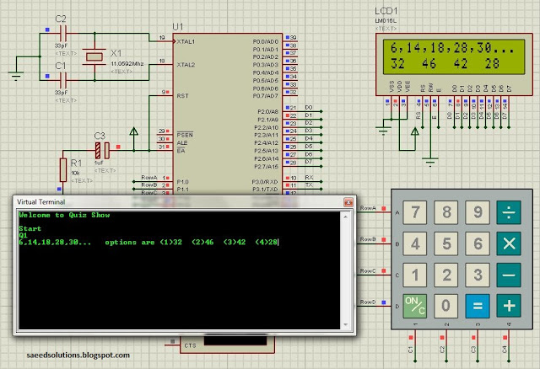
Figure 3. Q1 screen shot
By pressing '0' from the virtual terminal to answer the question, the question was answered by the userB. After that, question 2 screen shot is shown below.
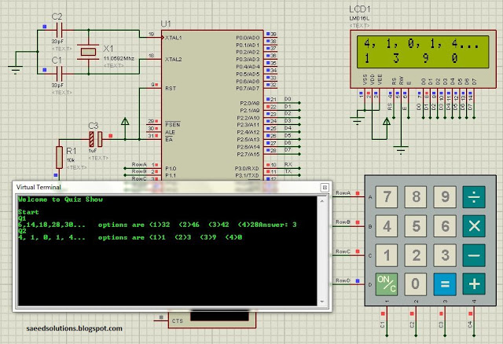
Figure 4. Q2 screen shot
Similarly all 3 questions were answered and finally, the results were shown. These are also shown below in the figure.
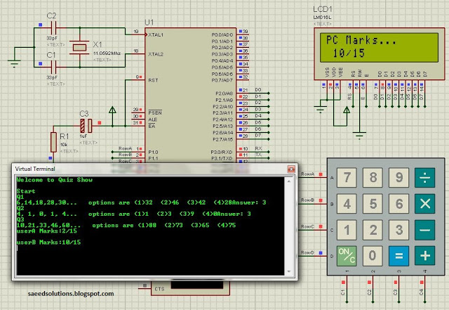
Figure 5. Result screen shot
UserA has 2 points and UserB has 10 points, hence UserB wins.
You can leave your comments in the comment section below.

